Meter Bag Guidelines
Curb space downtown is a valuable and limited resource. For this reason, the DDA discourages the use of meter bags except when necessary. Additionally, the DDA recognizes that there is a beneﬁt to repurposing metered on-street spaces for uses other than parking when the use serves to activate public space. Meter bags will be provided in support of those activities that complement the DDA’s mission to strengthen downtown and meet the DDA’s Development Plan Goals:
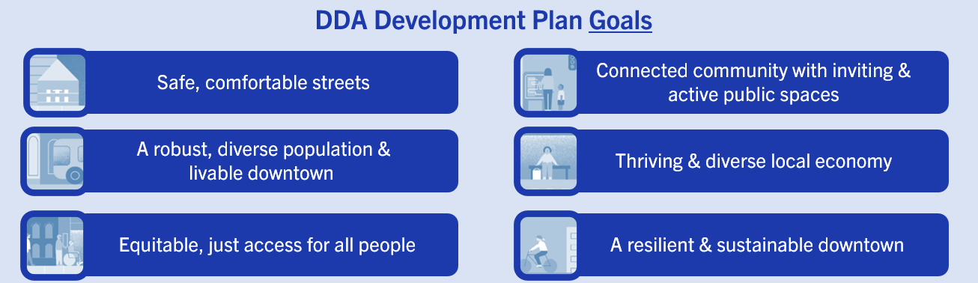

Commercial Meter Bags
Commercial meter bags are intended to reserve parking spaces for commercially plated vehicles. Meter bags can be requested to accommodate service or trade vehicles, deliveries, dumpsters, or moving vehicles. If the space is to be utilized for something other than a vehicle, a City of Ann Arbor issued barricade permit is required. If the space is to be used for construction staging or work areas, a City of Ann Arbor Lane closure permit is required.
Meter bags are $30.00 per space per day Monday-Saturday. Meter bags requested for a Sunday or holiday, when parking is free, require an administrative fee of $200 or $400 based on the number of bags requested. Requests that include the temporary removal of meter posts or pay stations require additional fees.

Relevant guidelines from PCI Meter Bag Agreement (see agreement for additional details)
- Only commercially licensed vehicles may utilize space(s). Commercial plates typically have 2 letters
followed by 4-5 numbers.
- The meter bag rental will provide a direct tangible service to the property owner/tenant and/or City.
- The meters occupied should be the closest to the premises where the work is being performed.

Special Event Meter Bags
Special event meter bags are intended to reserve parking for special events. These requests can be for event related vehicles or required as part of a street closure approved by the City of Ann Arbor. When not part of an approved street closure, special event meter bag spaces are limited in number, duration, and location at the discretion of the DDA or its parking operator.
Meter bags are $30 per space per day Monday-Saturday. Meter bags requested for a Sunday or holiday, when parking is free, require an administrative fee of $200 or $400 based on the number of bags requested.

Relevant guidelines from PCI Meter Bag Agreement (see agreement for additional details)
- The event will draw significant numbers of people to or will significantly enhance downtown economically.
- The space(s) will be used for an operational motor vehicle, or the space is located within an area covered by
a street closure permit from the City of Ann Arbor.
- The request for the meter bags must be made by the event organizer.
- Special Event meter bags will be limited to 5 days unless approved by the DDA.

Meter Bags for Curbside Occupancy Permits
The DDA issues meter bags to facilitate the installation of a curbside structure following the issuance of a City of Ann Arbor curbside occupancy permit. These seasonal curbside occupancy permits allow for the repurposing of the street into an active space. These spaces serve as an economic development tool as well as help to activate the public realm. Meter bags for this purpose are provided at a reduced rate of
$50.00/month, plus an annual $250.00 administrative fee. Administrative fee and monthly fees are
to be paid prior to installation, are non-refundable and are not pro-rated.
Curbside structure design requirements and process information can be found on the City of Ann Arbor’s
website- https://www.a2gov.org/services/Pages/Sidewalk-Occupancy-Permit-.aspx#CurbsideOccupancy

Meter Bag Fee Waiver Guidelines
Should an event organizer request that meter bag fees be waived, the DDA will consider the following elements when making a waiver determination. Please note that waiver does not guarantee waiver in future years, or for similar events. Request for fee waiver should be made in writing to the DDA (parking@a2dda.org) and should speak to the below elements where applicable.
  - Does the event organizer have non-profit status (i.e., 501c)?
  - Does the event have a substantial charitable component?
  - Does the event draw significant numbers of people to or significantly enhance the downtown
economically?
  - Is the event open to the public?
  - In there a cost to participate in or attend the event?
  - Does the event promote a business or for-profit company?
  - Will the event organizer include DDA in the list of sponsors?
  - New Event: Provide a summary of the event and the marketing/engagement plan.
  - Are the spaces being used to facilitate active loading/unloading?
  - Are the spaces being used to facilitate staging and/or deliveries crucial to the event that would be infeasible or impractical elsewhere?

The DDA manages the public parking system in support of DDA goals and uses the waiver of meter bag fees as the tool for the parking system to support events that contribute to downtown economic health and vibrancy. Spaces for which a meter bag fee waiver is requested should be used in alignment with the above guidelines. The DDA does not waive fees to provide event employee or volunteer parking. The DDA does not waive or discount parking rates (permit or hourly) in support of events.

These guidelines will be implemented by the parking operator and DDA staff.

The Ann Arbor DDA may revisit and update this policy as necessary. All fees and rates are subject to change.

