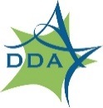
Memorandum

To: Ann Arbor Commission on Disability Issues

From: Nani Wolf, DDA Planning Specialist
Date: November 13, 2025
Subject: Fourth Avenue Street Redesign Project

Fourth Avenue Project Overview
The Downtown Development Authority (DDA) is currently funding a re-design of Fourth Avenue between William Street and Liberty Street. The Fourth Avenue project will emphasize improved access, safety, equity, and sustainability. The project will be a complete road and sidewalk reconstruction from edge-to-edge. New features planned for Fourth Avenue include: street trees, benches, lighting, curbs and sidewalks, pedestrian crossings, dedicated bus loading lanes, bus shelters, public art, and more. Underground, the water, stormwater, and gas lines will also be upgraded.
The project area is directly adjacent to the Blake Transit Center and the future 350 South Fifth housing development, which is a private development project that will provide new affordable housing units. This project is being conducted in coordination with the City of Ann Arbor Public Services, Ann Arbor Area Transportation Authority (TheRide), Ann Arbor Housing Commission (AAHC), and DTE energy. The project team is finalizing the design, with construction scheduled to begin in spring 2026.

Existing Conditions on Fourth Avenue

Current Pedestrian Street Design
The project area has very high pedestrian traffic due to the presence of the Blake Transit Center, the central hub for TheRide. There are two pedestrian crossings across Fourth Avenue: one at William Street and one at Liberty Street. Both intersections have traditional traffic signals, white stripe pavement marking, truncated dome tactile pads, and pedestrian countdown signals without audible indicators.
Photo 1: View of Fourth Avenue from midblock standing on the east side of the street, facing north.
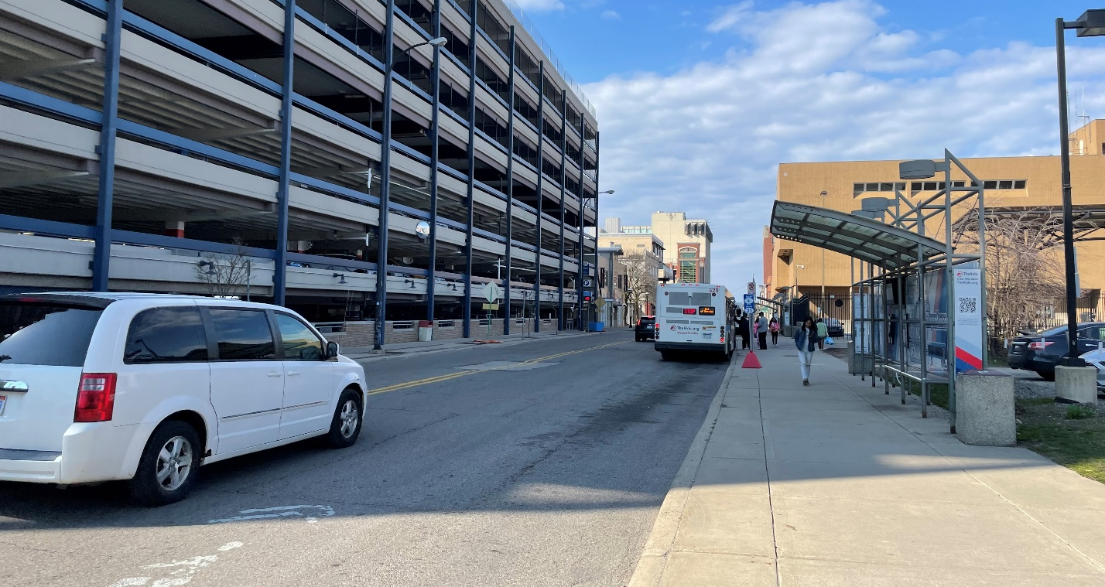

Analyzing Pedestrian Safety Needs
Pedestrian movements along Fourth Avenue were analyzed and several different crosswalk options were evaluated using the City of Ann Arbor Crosswalk Design Guidelines. The analysis recommended adding a midblock crosswalk to accommodate future pedestrian trips, which will rise as the Blake Transit Center expands and 350 South Fifth site is redeveloped. As such, the proposed design for Fourth Avenue now features a midblock crosswalk, in addition to the crosswalks at William and Liberty Streets.
The new midblock crosswalk on Fourth Avenue will include warning signs and high visibility markings.

Accessibility Features for Consideration
The project will include audible pedestrian signals at both intersection crosswalks. We strive to ensure that the physical street design for Fourth Avenue provides safe travel for all people.
To ensure the midblock and corner crossings are navigable for all users, the DDA is considering tactile pavers above and beyond the standard truncated domes that are provided at crosswalks. Specifically, we are seeking the Commission’s feedback on tactile guide strips along the midblock crossing. There is a slight jog in the pedestrian walking path at each midblock crossing, and our goal is to ensure that all users can navigate this jog safely and predictably.
Photo 2: Aerial view of the street design plans, showing the slight jogs (highlighted in yellow) in the sidewalk path on either side of the midblock crossing. The accessible sidewalk path shifts from building side to curb side to accommodate new, large transit shelters.
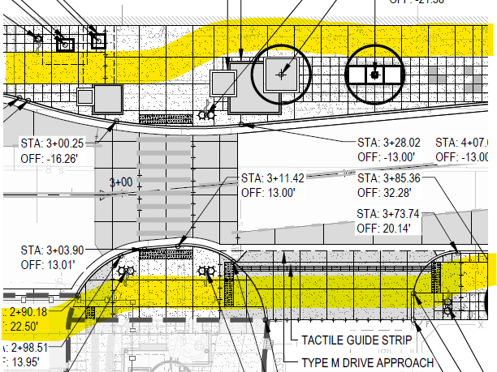

The current design proposes a tactile guide strip along the driveway entrance to the Blake Transit Center, located on the east side of the street.
Photo 3: Aerial view of the street design plans, showing the required truncated domes at crossing (highlighted in blue) and proposed directional tactile pavers along the Blake Transit Center driveway entrance (highlighted in yellow).
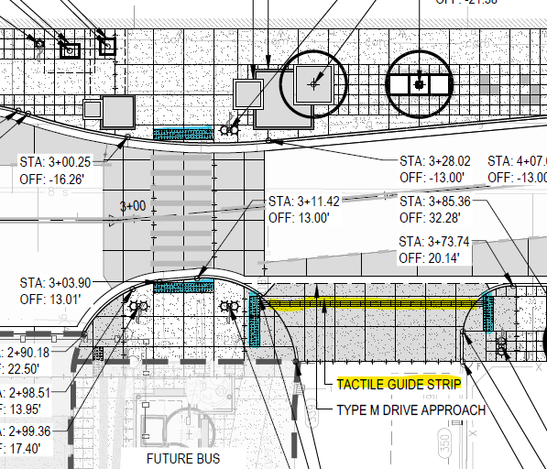
We are seeking feedback on whether these directional, tactile strips should be used to delineate the jogs in the walking paths on either side of the midblock crosswalk.

We would also appreciate feedback on whether the tactile warning devices (truncated domes) should be added on either side of the driveway exit from the parking structure, located on the east side of the street.
Photo 4: Current condition of the Fourth and William Parking Structure, showing the driveway approach, sidewalk, and conditions for pedestrians.
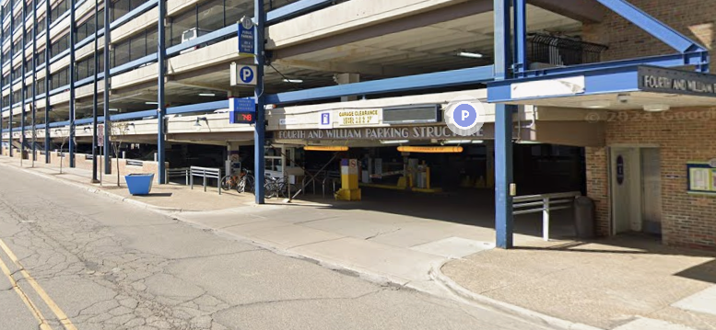

Project Timeline and Next Steps

Phasing and Deadlines
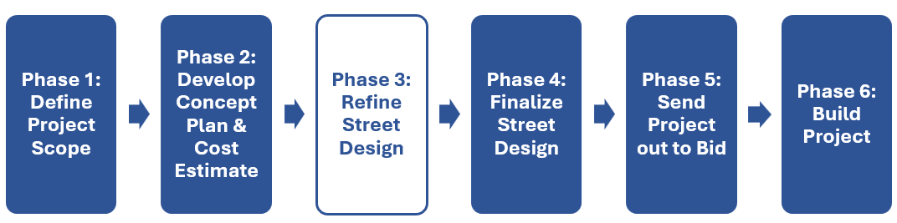
Deadline for Phase 3: End of November.
Deadline for Phase 4: Mid-December.

How and When to Provide Feedback
The DDA team will be present at the November 19, 2025 meeting of the Commission on Disability Issues, and we welcome your feedback on the project design at this time. You can also provide written feedback via email to nwolf@a2dda.org. Finally, we will be conducting a site visit on Thursday, November 20 at 2pm. If you would like to attend the site visit, please let a DDA representative know and we will send you the calendar invite and location of the meeting.
Please provide all feedback by November 24, 2025.

Concluding Remarks
We strive to make our downtown a safe, welcoming, and vibrant place for all people. On behalf of all staff at the DDA, we thank you for your time and careful consideration of our project.

Sincerely,
Amber Miller, DDA Capital Projects & Planning Manager
Nani Wolf, DDA Planning Specialist
Shelby Fergon, DDA Planning Specialist

