
Memorandum

To: Ann Arbor Commission on Disability Issues.

From: Nani Wolf, DDA Planning Specialist.
Date: December 4, 2025.
Subject: Fourth Avenue Street Redesign Project, Accessibility Review Outcome.

Summary of Meetings and Feedback
On November 19, 2025, the Downtown Development Authority (DDA) attended the Commission on Disability Issues meeting to solicit feedback on the proposed street design for Fourth Avenue. The team sought feedback on the use of tactile pavers to warn pedestrians of driveway approaches and crosswalks, as well as to guide people along the walking path in specific segments.
The Commission provided the following points of feedback:
- Commissioners expressed general approval for the tactile paver plan and had no specific comments.
- Commissioners suggested adding small projecting signs reading “Vehicles Exiting” to either side of the parking structure approach at eye level. Commissioners also suggested adding a LED sign which illuminates to read “Warning Vehicles Exiting” when a vehicle triggers it.
- Commissioners suggested adding an Audible Pedestrian Signal to the mid-block crosswalk. Commissioners also suggested adding a combination of APS and a flashing pedestrian signal to the mid-block crosswalk.
On November 20, 2025, Will Purves, a representative of the Disability Network of Michigan who is legally blind, attended a site visit with the DDA team on Fourth Avenue. In addition to echoing the suggestions of the Commission, he provided the following feedback:
- He suggested differentiating the pavement texture between the walking zone and the curbside amenity zone, where trees, benches, bike hoops, and streetlights will be installed.
- He supported the proposed tactile directional tiles in both texture and location.
- He suggested adding an Audible Pedestrian Signal to the mid-block crosswalk.

Final Street Design
Considering the comments provided, the following new elements have been incorporated into the final Fourth Avenue project design.
- An Audible Pedestrian Signals and RRFBs, which are a flashing beacon to indicate crossing, have been added to the mid-block crosswalk.
- Audible Pedestrian Signals have been added to the Liberty Street intersection on all four corners and will accompany the existing traffic signal.
- The underground infrastructure for Audible Pedestrian Signals has been added to the William Street intersection, to accommodate the signals when they are installed at a future date. The Fourth Avenue Reconstruction project boundary does not cover the William Street intersection, so the final signal installation cannot be completed as a part of the project. When installed in the future, the Audible Pedestrian Signals will be on all four corners and accompany the existing traffic signal.
- A sign at the exit of the parking structure is being explored to warn approaching pedestrians when cars are exiting the structure. The exact design of this sign is to be determined.
- A texture has been added to the pavement in the amenity zone, to distinguish it from the walking zone of the sidewalk.

Project Timeline and Next Steps

Phasing and Deadlines
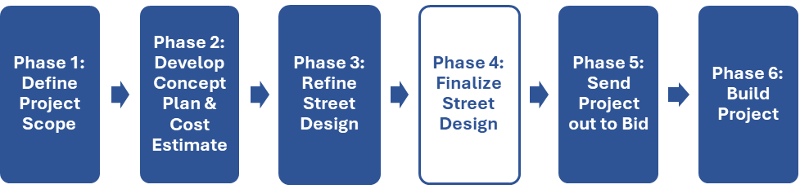
Deadline for Phase 4: December 10, 2025.
Deadline for Phase 5: December 18, 2025.

Concluding Remarks
We strive to make our downtown a safe, welcoming, and vibrant place for all people. On behalf of all staff at the DDA, we thank you for your time and careful consideration of our project.

Sincerely,
Amber Miller, DDA Capital Projects & Planning Manager
Nani Wolf, DDA Planning Specialist
Shelby Fergon, DDA Planning Specialist

